|  |  |
| --- | --- |
| Image result for new york skyline vertoca;"  **FRAUD ANALYTICS PROJECT 1**  New York Property | ABSTRACT  Design an unsupervised fraud model to find anomalies in New York property data  Team 9  Anni Cai, Suraj Patel, Yuyao Shen, Nanchun Shi, Bingru Xue |

# Contents

Executive Summary 2

Description of Data 3

Data Cleaning 4

Variable Creation 5

Dimensionality Reduction 6

Algorithms 7

Results 8

Conclusions 9

Appendix 16

# Executive Summary

Team 9 proposed to design an unsupervised fraud detection algorithm at the request of the City of New York. The goal for this project is to find unusual valuations: Total Market Value (FULLVAL), Actual Land Value (AVLAND) and Actual Total Value (AVTOT) from “NY property data” dataset which has 1,070,994 records and 32 variables.

After imputation for missing values, we created new variables to best represent these value fields to look for anomalies. For example, we normalized value fields by lot area, building area and building volume and grouped them by five different levels of granularity and after that, we had 45 variables. Then, we implemented Principal Component Analysis to remove correlations and reduce dimensions.

Upon the completion of data preparation, we applied two outlier detection methods (Heuristic Function and Autoencoder) to generate an abnormal score for each record and normalized it by taking its rank order then combined these two scores by taking their average to get final anomaly score for each record.

As a result, we have a list of records sorted by its abnormality and we recommend the City of New York to start investigating from top 10.

# Description of Data

**Description of data**

This dataset is from New York City OpenData, which includes the valuation and assessment of properties in New York City assessed in 2010 and 2011. It has 1070994 records and 32 variables.

**Numeric Fields**

|  |  |  |  |  |  |  |  |  |  |
| --- | --- | --- | --- | --- | --- | --- | --- | --- | --- |
| Field name | Field type | # of non-NA values | % populated | # unique values | # '0' records | Mean | Std | Min | Max |
| LTFRONT | numeric | 1,070,994 | 100 | 1,297 | 169,108 | 36.64 | 74.03 | 0 | 9,999 |
| LTDEPTH | numeric | 1,070,994 | 100 | 1,370 | 170,128 | 88.86 | 76.4 | 0 | 9,999 |
| STORIES | numeric | 1,014,730 | 94.75 | 111 | 0 | 5.01 | 8.37 | 1 | 119 |
| FULLVAL | numeric | 1,070,994 | 100 | 109,324 | 13,007 | 874,264.51 | 11,582,430.99 | 0 | 6,150,000,000 |
| AVLAND | numeric | 1,070,994 | 100 | 70,921 | 13,009 | 85,067.92 | 4,057,260.06 | 0 | 2,668,500,000 |
| AVTOT | numeric | 1,070,994 | 100 | 112,914 | 13,007 | 227,238.17 | 6,877,529.31 | 0 | 4,668,308,947 |
| EXLAND | numeric | 1,070,994 | 100 | 33,419 | 491,699 | 36,423.89 | 3,981,575.79 | 0 | 2,668,500,000 |
| EXTOT | numeric | 1,070,994 | 100 | 64,255 | 432,572 | 91,186.98 | 6,508,402.82 | 0 | 4,668,308,947 |
| BLDFRONT | numeric | 1,070,994 | 100 | 612 | 228,815 | 23.04 | 35.58 | 0 | 7,575 |
| BLDDEPTH | numeric | 1,070,994 | 100 | 621 | 228,853 | 39.92 | 42.71 | 0 | 9,393 |
| AVLAND2 | numeric | 282,726 | 26.40 | 58,591 | 0 | 246,235.72 | 6,178,962.56 | 3 | 2,371,005,000 |
| AVTOT2 | numeric | 282,732 | 26.40 | 111,360 | 0 | 713,911.44 | 11,652,528.95 | 3 | 4,501,180,002 |
| EXLAND2 | numeric | 87,449 | 8.17 | 22,195 | 0 | 351,235.68 | 10,802,212.67 | 1 | 2,371,005,000 |
| EXTOT2 | numeric | 130,828 | 12.22 | 48,348 | 0 | 656,768.28 | 16,072,510.17 | 7 | 450,1180,002 |

**Categorical Fields**

|  |  |  |  |  |  |
| --- | --- | --- | --- | --- | --- |
| Field name | Field type | # of non-NA values | % populated | # unique values | Most Common Field |
| Record | categorical | 1,070,994 | 100 | 1,070,994 | NA |
| BBLE | categorical | 1,070,994 | 100 | 1,070,994 | NA |
| B | categorical | 1,070,994 | 100 | 5 | 4 |
| BLOCK | categorical | 1,070,994 | 100 | 13,984 | 3944 |
| LOT | categorical | 1,070,994 | 100 | 6,366 | 1 |
| EASEMENT | categorical | 4,636 | 0.43 | 12 | E |
| OWNER | categorical | 1,039,249 | 97.04 | 863,346 | PARKCHESTER PRESERVAT |
| BLDGCL | categorical | 1,070,994 | 100 | 200 | R4 |
| TAXCLASS | categorical | 1,070,994 | 100 | 11 | 1 |
| EXT | categorical | 354,305 | 33.08 | 3 | G |
| EXCD1 | categorical | 638,488 | 59.62 | 129 | 1017 |
| STADDR | categorical | 1,070,318 | 99.94 | 839,280 | 501 SURF AVENUE |
| ZIP | categorical | 1,041,104 | 97.21 | 196 | 10314 |
| EXMPTCL | categorical | 15,579 | 1.45 | 14 | X1 |
| EXCD2 | categorical | 92,948 | 8.68 | 60 | 1017 |
| PERIOD | categorical | 1,070,994 | 100 | 1 | FINAL |
| YEAR | date/time | 1,070,994 | 100 | 1 | 2010/11 |
| VALTYPE | categorical | 1,070,994 | 100 | 1 | AC-TR |

**Important Distributions/Histograms:**

**FULLVAL**

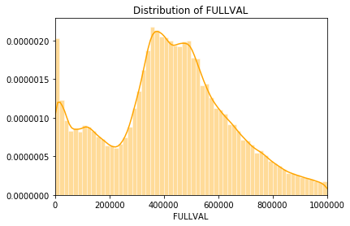

**AVTOT**

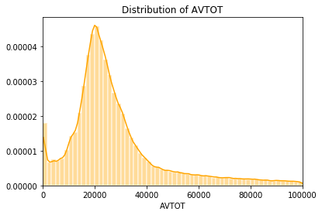

**AVLAND**

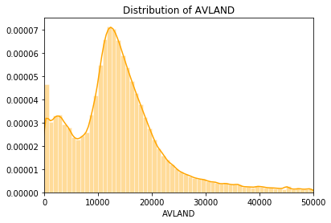

# Data Cleaning

We first imputed **ZIP** because zip code is the prerequisite for imputing other variables. We grouped the ZIP data by borough and block and distinguished two kinds of all groups: one with all null values, and the other with at least one non-null value. For the groups with all null values, we filled in their zip codes based on their street addresses. If the street address doesn’t exist as well, we used the minimum zip code in that borough. For the groups with at least one non-null value, we used the most common zip code in the group to fill in.

For **FULLVAL, BLDFRONT, BLDDEPTH, LTFRONT, LTDEPTH** and **STORIES**, we first grouped by zip code and building class and moved along in the following order if there existed a group with less than 5 records:

1. Group by zip code and building class (ZIP, BLDGCL)
2. Group by zip code and tax class (ZIP, TAXCLASS)
3. Group by zip code only (ZIP)
4. Group by borough (B)

We filled in missing fields with the median value of that group.

We believed AVTOTis highly related to building size, therefore we derived the following formula to calculate building value per square foot (BVPSF) for the imputation of AVTOT:

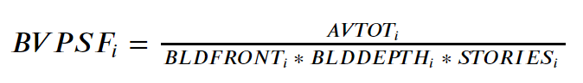

Since we already filled in BLDFRONT, BLDDEPTH and STORIES, we were ready to calculate BVPSF. Again, we aggregated data into groups, and we set different levels of granularity to avoid data scarcity (less than 5 records in a group) as follow:

1. Group by zip code and building class (ZIP, BLDGCL)
2. Group by zip code and tax class (ZIP, TAXCLASS)
3. Group by zip code (ZIP)
4. Group by borough (B)

We took the median BVPSF in each group and multiplied by estimating property’s useable building area (BLDFRONT*BLDDEPTH*STORY) to get its estimated AVTOT.

For **AVLAND**, we used the same logic for the hierarchy of grouping as well as for dealing with data scarcity. We first calculated land value per square foot (LVPSF) for each record:

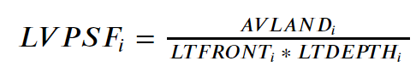

Then for each record with missing AVLAND value, we use the median of its proper group and multiplied by its LTFRONT and LTDEPTH to obtain an estimated land value for the record.

# Variable Creation

Firstly, we created 3 size variables:

1. LOTAREA (S1) = LTFRONT * LTDEPTH
2. BLDAREA (S2) = BLDFRONT * BLDDEPTH
3. BLDVOL (S3) = BLDAREA * STORIES

Then we normalized 3 value variables (V1 = FULLVAL, V2 = AVLAND, V3 = AVTOT) using these 3 size variables above:

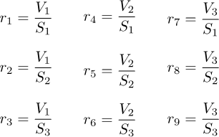

After that, we separated records into 5 groups: 3-digit zip code, 5-digit zip code, tax class, borough and all. For each group g, we calculated rig , the average of each ri for each group g. And for each record, we calculated and appended 45 variables:



# Dimensionality Reduction

After we created 45 ratios, we z-scaled the dataframe. Then we conduct Principal Component Analysis.

Below is the scree plot:

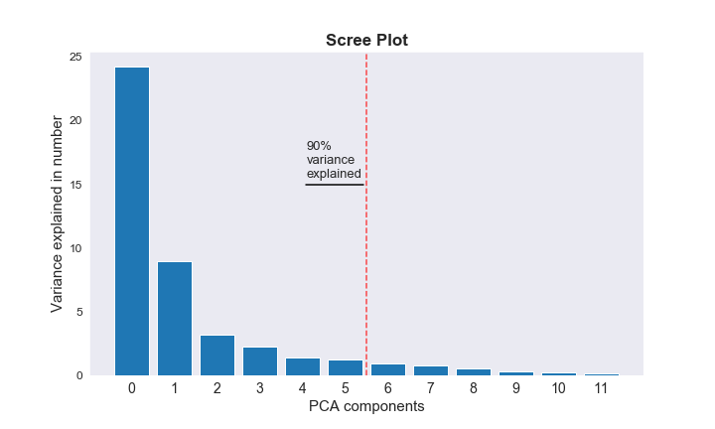

We chose the first 5 components that explained about 90% variance of the original z-scaled data.

Then we z-scale again and obtained the dataset with shape (1070994,5) ready for scoring.

# Algorithms

**Heuristic Function:**

We used the following function to calculate the first score:

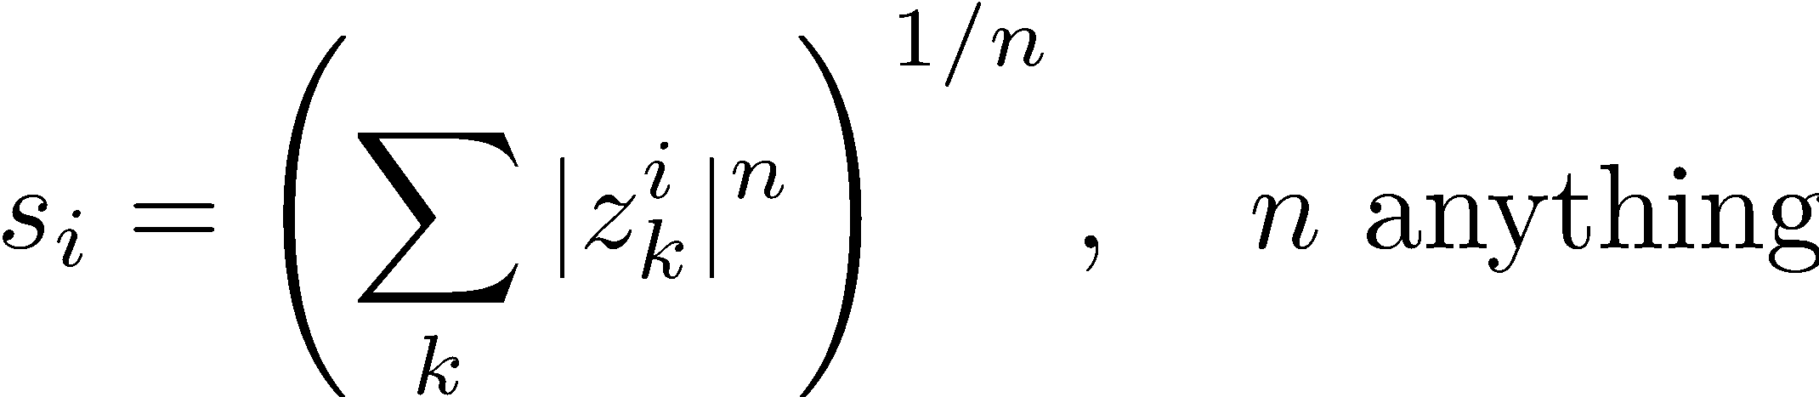

where z represents PC values for each record and here we chose n to be 2.

**Autoencoder:**

We built an autoencoder model from keras library, set one hidden layer with two nodes, trying to reproduce z-scaled PCs. Then we combined PCs with encoded PCs using the following function:

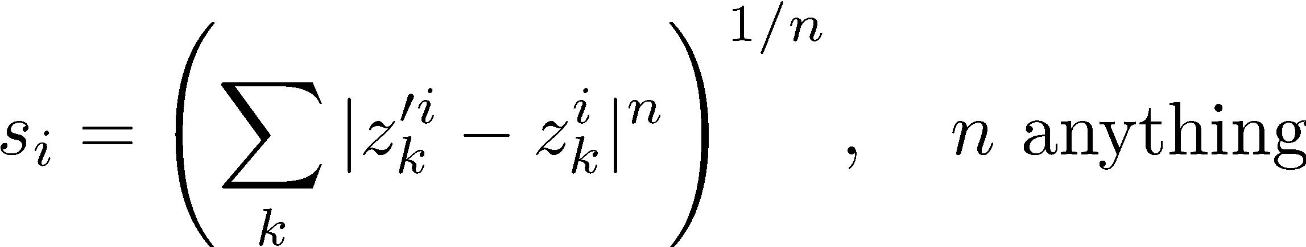

where z’s represent PC and encoded PC, and here we chose n to be 2.

**Combining two scores:**

We rank score 1 and score 2 and created two rank order columns, then combined rank orders using the average. We sorted the dataset by final score and picked the top ten records that seem to be abnormal.

# Results

**Below are the plots of two score distributions:**

For the Heuristic Function:

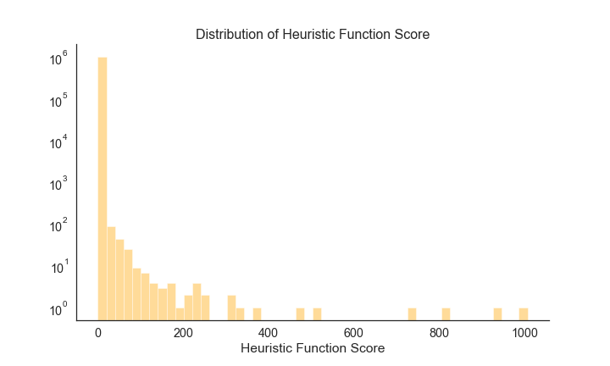

For the Autoencoder:

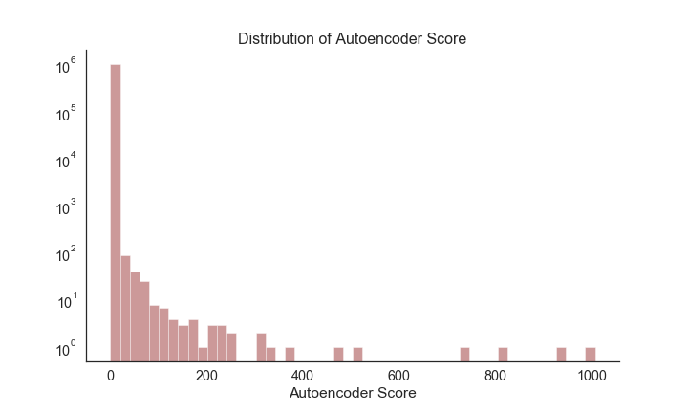

As explained in the previous section, we then combined the two scores for final anomaly detection.

The top 10 presumably abnormal records are as follows. We went back to the z-scaled ratios table as well as the original dataset to track down the potential anomalies:

|  |  |
| --- | --- |
| RECORD | REASON FOR ANOMALIES |
| #632816 | The z-scores of r2, r3, r5, r6, r8 and r9, which are related to building size and building volume, are extremely high and the reason is its BLDFRONT and BLDDEPTH are 1. |
| #565392 | Both BLDFRONT and BLDDEPTH are below 50 percentiles of its group, but its FULLVAL, AVTOT and AVLAND are all above 75 percentiles of its group. We went back to the original data set and found that Its AVTOT, AVLAND, EXLAND and EXTOT are all 1,946,837,000. It might be inappropriate to fill in a median value for this record in the fields of BLDFRONT and BLDDEPTH. |
| #1067360 | For this record, the z-scores of r1 (FULLVAL/ (LOTFRONT * LOTDEPTH)) and r4 (AVLAND/ (LOTFRONT * LOTDEPTH)), and r7 (AVTOT/ (LOTFRONT * LOTDEPTH)) are extremely high. These ratios are all related to lot size. So, we checked the relevant variables in the original dataset and found that LTFRONT =1, LTDEPTH = 1, which are abnormal. |
| #917942 | For this record, the z-scores for r8 are considered high and abnormal because they are above 75 percentiles. Since r8 = v3/s2 = actual total value/ building area, we looked for anomalies in AVTOT, BLDFRONT or BLDDEPTH. We investigated and found that the LTDEPTH (100), BLDFRONT (40) and BLDDEPTH (60) are imputed by us, and their values are relatively small compared to LTFRONT (4910). This record is therefore marked as anomaly because the imputed values are not in consistency with LTFRONT in terms of scale. And this address turned out to be a 7-story Holiday Inn close to JFK. |
| #585118 | For this record, the z-scores of r2 (FULLVAL/ (BLDFRONT * BLDDEPTH)) and r5(AVLAND/ (BLDFRONT * BLDDEPTH)), and r8 (AVTOT/ (BLDFRONT * BLDDEPTH)) are extremely high. These ratios are all related to building size. So, we checked the relevant variables in the original dataset and found that BLDFRONT =1, BLDDEPTH = 1, which are abnormal. Used the street address, to find that it is an empty plot with no building construction. Also, the FULLVAL, AVLAND and AVTOT have values higher than 75% of the dataset. |
| #585439 | The z-scores of r2 (FULLVAL/(BLDFRONT * BLDDEPTH)) in all groups are very big and the reason is its BLDFRONT and BLDDEPTH are all 1’s and itself is a 10-story 4-star hotel, which makes the z-score abnormally high. |
| #920628 | Its z-scores for r2 (FULLVAL/ (BLDFRONT * BLDDEPTH)) in all groups are high because its BLDFRONT and BLDDEPTH are all 1’s and itself is a nearly 4,000 square foot building size 2-story house. |
| #585120 | The z-scores of r2 (FULLVAL/ (BLDFRONT * BLDDEPTH)) in all groups are very big and the reason is its BLDFRONT and BLDDEPTH are all 1’s. |
| #565398 | The z-scores for r2, r3, r5, r6, r8, r9 are all big. Its FULLVAL, AVLAND and AVTOT have values greater than 75% of this dataset. And its LTFRONT and LTDEPTH are also greater than 75% of the dataset. It might be inappropriate to fill in a median value for this record in the fields of BLDFRONT and BLDDEPTH. |
| #1067001 | The z-scores of r2 (FULLVAL/ (BLDFRONT * BLDDEPTH)) in all groups are very big and the reason is its BLDFRONT and BLDDEPTH are all 1’s. |

# Conclusions

To conclude, our team identified the top 10 anomaly records in “NY property data” dataset with unusual valuations by building an unsupervised fraud detection model. We imputed missing values, built 45 variables to represent values fields, scaled and minimized dimensionality by z-scaling and PCA, and normalized reduced variables again. Finally, we applied both Heuristic algorithm and Autoencoder to get anomaly scores and used rank ordering to scale each score. Combining the results by weighted average rank orders, we obtained top anomaly records.  
  
More precise imputations have been left for the future due to lack of information and time. For example, properties with Tax Class Code “4” have high variations in both size and value variables. We need more detailed classification within this tax code group in order to impute more reasonable values.   
  
Besides, many properties received high anomaly scores due to their extremely low size values. In the future work, we need to verify whether these records were misinputed during the data collection process, or they are attempted frauds.

# Appendix - Data Quality Report

**TABLE OF CONTENTS**

**PART I - INTRODUCTION** **----------------------------------------------------------------------------- 14**

**PART II - SUMMARY OF DATASET** **------------------------------------------------------------------ 14**

**PART III - FIELD DESCRIPTION** **--------------------------------------------------------------------- 16**

# PART I - INTRODUCTION

The dataset of interest “NY property data”, a subset with selected fields and data of the dataset “Property Valuation and Assessment Data”, is compiled and updated annually by the Department of Finance, City of New York for purpose to calculate Property Tax, Grant eligible properties Exemptions and/or Abatements. The dataset is obtained from NYC OpenData website.

The dataset contains 32 different feature information of 1,070,994 properties in New York in November, 2010.

## **PART II - SUMMARY OF DATASET**

**Below are the summary tables for the 32 fields in the dataset:**

1. **Numerical fields:**

|  |  |  |  |  |  |  |  |  |
| --- | --- | --- | --- | --- | --- | --- | --- | --- |
| **Field Name** | **# of Records** | **% Populated** | **# Unique Values** | **# Records w/ value 0** | **Mean** | **Standard Deviation** | **Max** | **Min** |
| **RECORD** | 1070994 | 100% | 1070994 | 0 | 535497.5 | 309169.5 | 1070994 | 1 |
| **LTFRONT** | 1070994 | 100% | 1297 | 169108 | 36.6353 | 74.03284 | 9999 | 0 |
| **LTDEPTH** | 1070994 | 100% | 1370 | 170128 | 88.86159 | 76.39628 | 9999 | 0 |
| **STORIES** | 1014730 | 94.75% | 111 | 0 | 5.006918 | 8.365707 | 119 | 1 |
| **FULLVAL** | 1070994 | 100% | 109324 | 13007 | 874264.5 | 11582430 | 6150000000 | 0 |
| **AVLAND** | 1070994 | 100% | 70921 | 13009 | 85067.92 | 4057260 | 2668500000 | 0 |
| **AVTOT** | 1070994 | 100% | 112914 | 13007 | 227238.169 | 6877529 | 4668309000 | 0 |
| **EXLAND** | 1070994 | 100% | 33419 | 491699 | 36423.89 | 3981576 | 2668500000 | 0 |
| **EXTOT** | 1070994 | 100% | 64255 | 432572 | 91186.98 | 6508403 | 4668309000 | 0 |
| **BLDFRONT** | 1070994 | 100% | 612 | 228815 | 23.042 | 35.5797 | 7575 | 0 |
| **Field Name** | **# of Records** | **% Populated** | **# Unique Values** | **# Records w/ value 0** | **Mean** | **Standard Deviation** | **Max** | **Min** |
| **BLDDEPTH** | 1070994 | 100% | 621 | 228853 | 39.9228 | 42.707 | 9393 | 0 |
| **AVLAND2** | 282726 | 26.398% | 58591 | 0 | 246235.719 | 6178963 | 2371005000 | 3 |
| **AVTOT2** | 282732 | 26.399% | 111360 | 0 | 713911.436 | 11652530 | 4501180000 | 3 |
| **EXLAND2** | 87449 | 8.165% | 22195 | 0 | 351235.684 | 10902210 | 2371005000 | 1 |
| **EXTOT2** | 130828 | 12.216% | 48348 | 0 | 656768.282 | 16072510 | 4501180000 | 7 |

1. **Categorical fields:**

|  |  |  |  |  |
| --- | --- | --- | --- | --- |
| **Field Name** | **# of Records** | **% Populated** | **# Unique Values** | **Most Common Value** |
| **BBLE** | 1070994 | 100% | 1070994 | - |
| **B** | 1070994 | 100% | 5 | 4 |
| **BLOCK** | 1070994 | 100% | 13984 | 3944 |
| **LOT** | 1070994 | 100% | 6366 | 1 |
| **EASEMENT** | 4636 | 0.4329% | 12 | E |
| **OWNER** | 1039249 | 97.0359% | 863346 | PARKCHESTER PRESERVAT |
| **BLDGCL** | 1070994 | 100% | 200 | R4 |
| **TAXCLASS** | 1070994 | 100% | 11 | 1 |
| **EXT** | 354305 | 33.082% | 3 | G |
| **EXCD1** | 638488 | 59.616% | 129 | 1017 |
| **STADDR** | 1070318 | 99.937% | 839280 | 501 SURF AVENUE |
| **ZIP** | 1041104 | 97.209% | 196 | 10314 |
| **EXMPTCL** | 15579 | 1.455% | 14 | X1 |
| **EXCD2** | 92948 | 8.679% | 60 | 1017 |
| **PERIOD** | 1070994 | 100% | 1 | FINAL |
| **YEAR** | 1070994 | 100% | 1 | 2010/11 |
| **VALTYPE** | 1070994 | 100% | 1 | AC-TR |

## **PART III - FIELD DESCRIPTION**

**1.**

**Field name:** RECORD

**Field type:** int64

**Description:** unique index number for each record, ascending from 1 to 1070994.

**2.**

**Field name:** BBLE

**Field type:** object

**Description:** Concatenation of BORO code, BLOCK code, LOT code, and EASEMENT code. Unique for each record.

**3.**

**Field name:** B

**Field type:** int64

**Description:** BOROUGH code; 1 = MANHATTAN, 2 = BRONX, 3 = BROOKLYN, 4 = QUEENS, 5 = STATEN ISLAND.

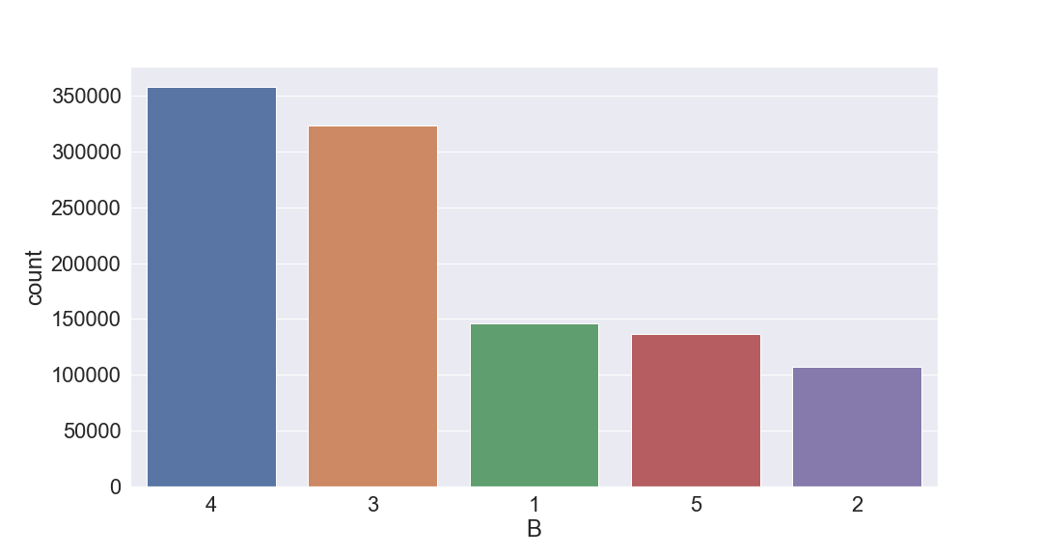

**4.**

**Field name:** BLOCK

**Field type:** int64

**Description:** valid block ranges by BORO; MANHATTAN 1 to 2,255, BRONX 2,260 to 5,958, BROOKLYN 1 to 8,955, QUEENS 1 to 16,350, STATEN ISLAND 1 to 8,050.

Manhattan:

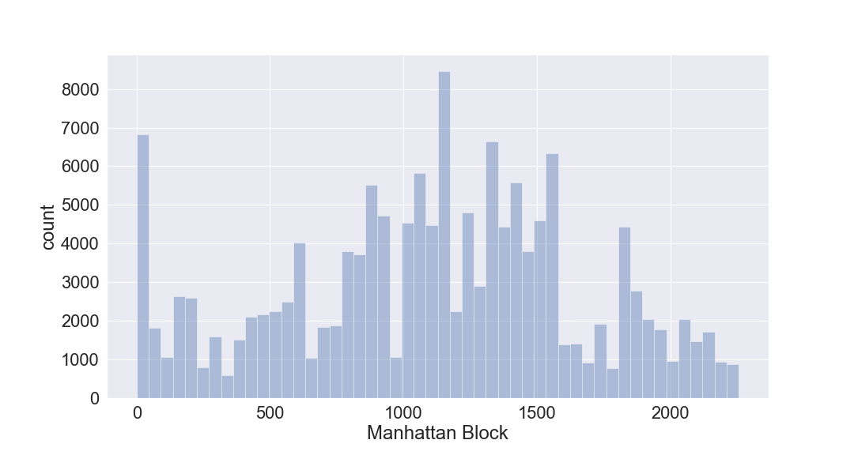

Bronx:

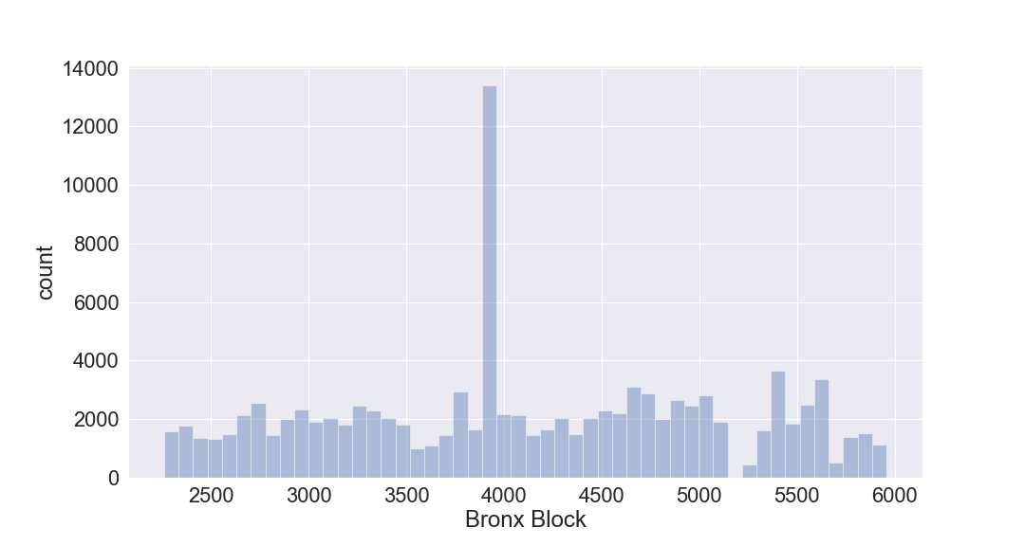

Brooklyn:

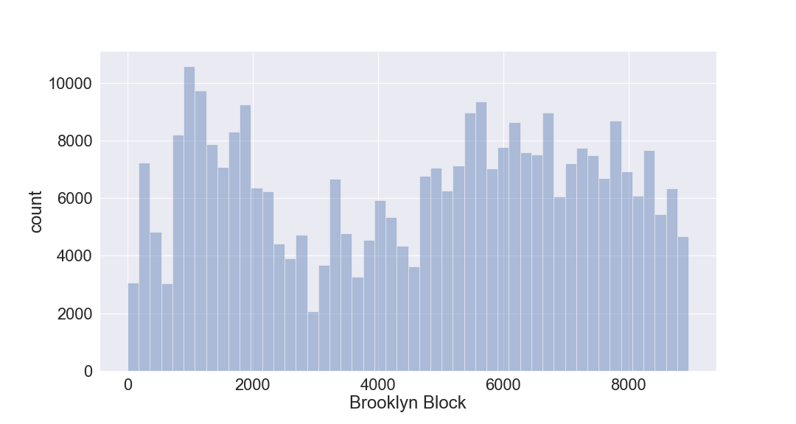

Queens:

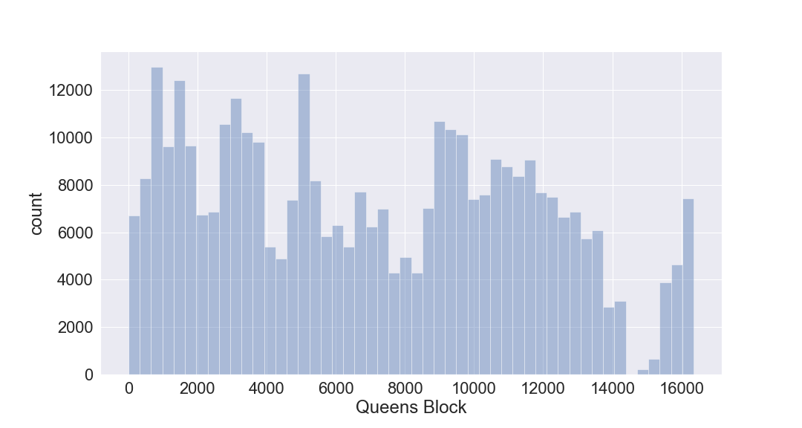

Staten Island:

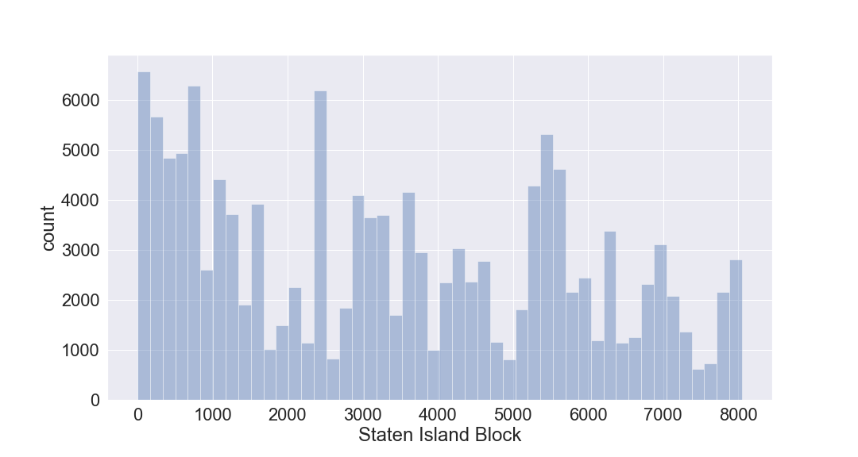

**5.**

**Field name:** LOT

**Field type:** int64

**Description:** unique number within BORO/BLOCK

Manhattan:

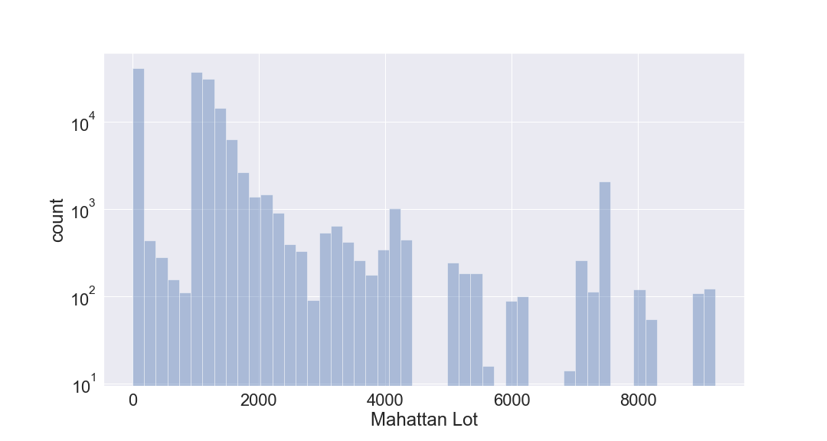

Bronx:

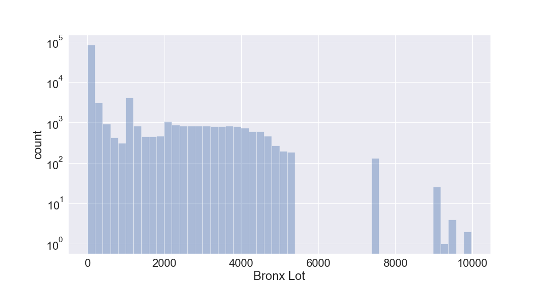

Brooklyn:

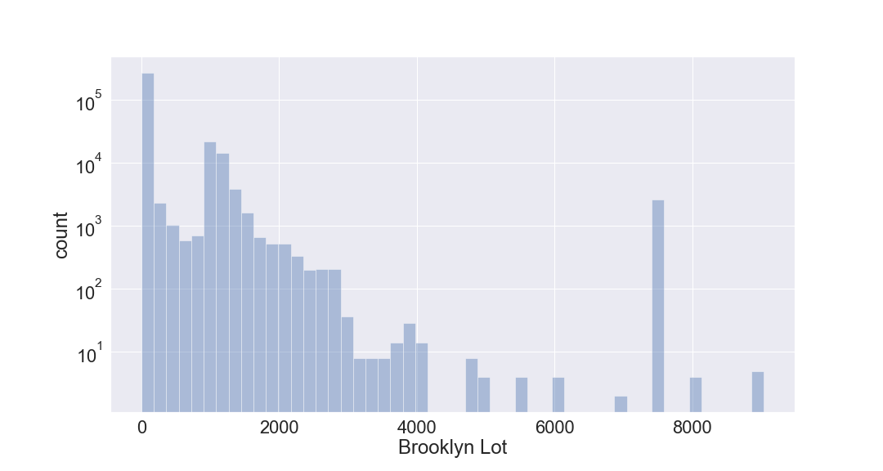

Queens:

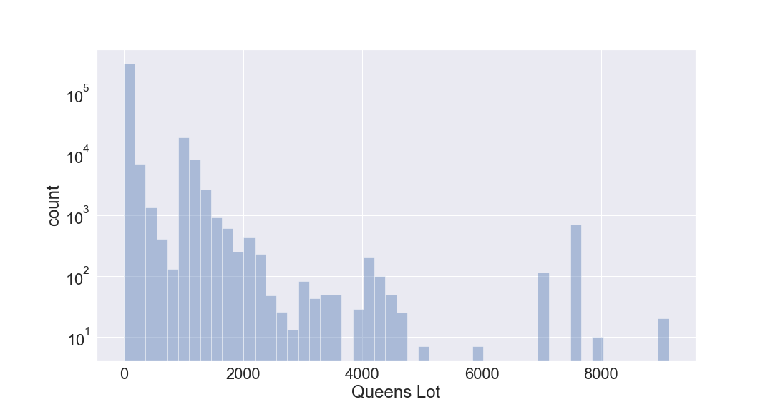

Staten Island:

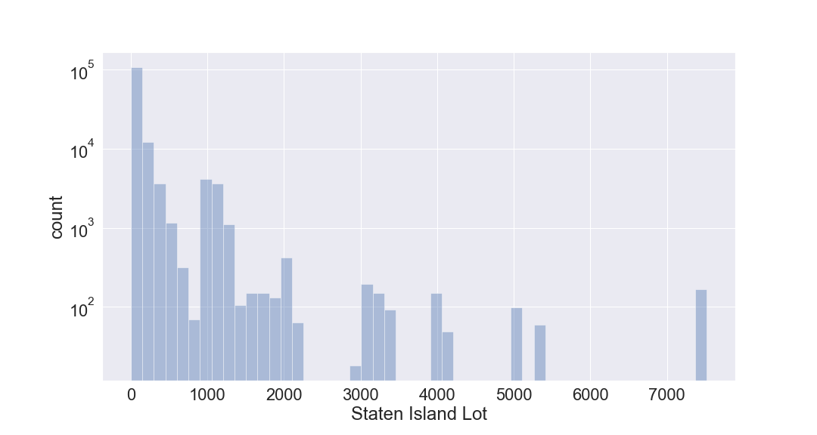

**6.**

**Field name:** EASEMENT

**Field type:** object

**Description:** SPACE Indicates the lot has no Easement.

'A' Indicates the portion of the Lot that has an Air Easement

'B' Indicates Non-Air Rights.

'E' Indicates the portion of the lot that has a Land Easement

'F' THRU 'M' Are duplicates of 'E'.

'N' Indicates Non-Transit Easement

'P' Indicates Piers.

'R' Indicates Railroads.

'S' Indicates Street

'U' Indicates U.S. Government

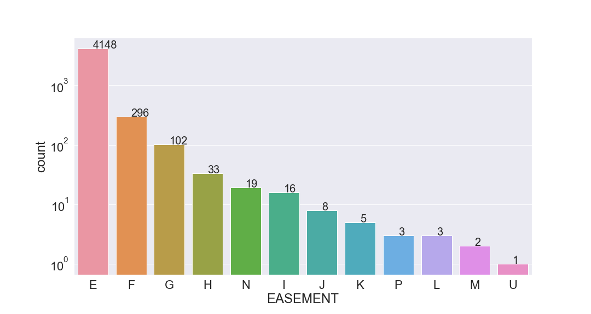

**7.**

**Field name:** OWNER

**Field type:** object

**Description:** owner names of the properties.

Top 25 owners with most properties: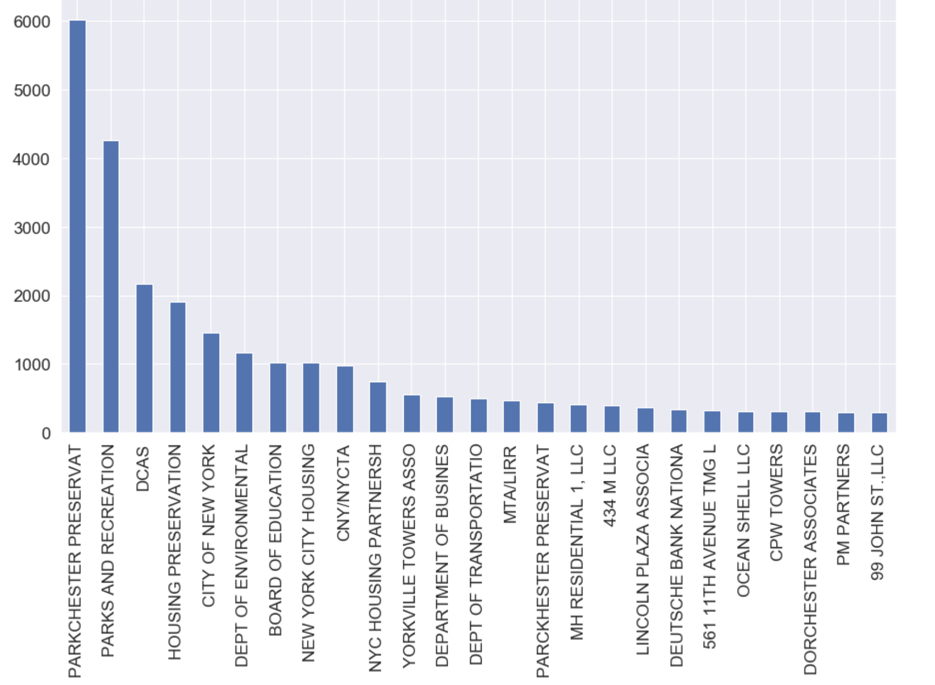

**8.**

**Field name:** BLDGCL

**Field type:** object

**Description:** building class. There is a direct correlation between the Building Class and the Tax Class.

Top 10 frequent building classes:

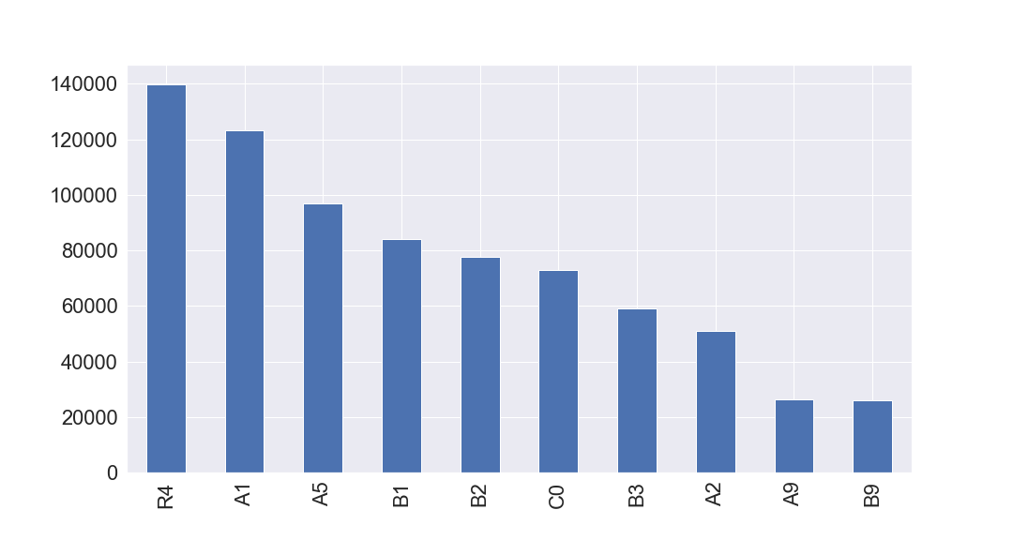

**9.**

**Field name:** TAXCLASS

**Field type:** object

**Description:** current Property Tax Class Code (NYS Classification);

tax class 1 = 1-3 unit residences

tax class 1a = 1-3 story condominiums originally a condo

tax class 1b = residential vacant land

tax class 1c = 1-3 unit condominiums originally tax class 1

tax class 1d = select bungalow colonies

tax class 2 = apartments

tax class 2a = apartments with 4-6 units

tax class 2b = apartments with 7-10 units

tax class 2c = coops/condos with 2-10 units

tax class 3 = utilities (except ceiling rr)

tax class 4a = utilities - ceiling railroads

tax class 4 = all others

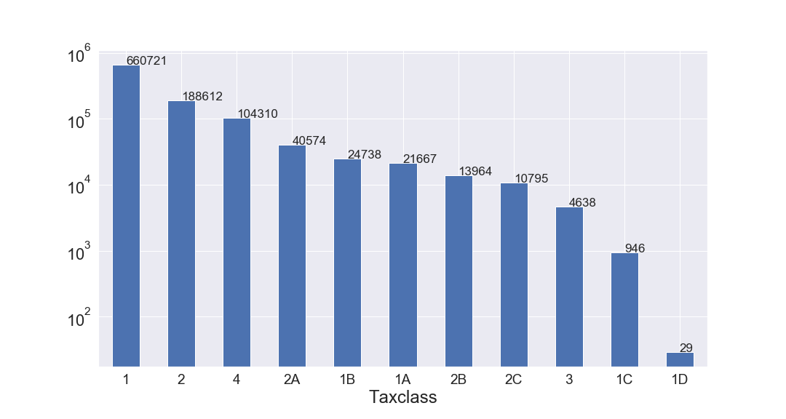

**10.**

**Field name:** LTFRONT

**Field type:** int64

**Description:** lot frontage in feet.

Properties that have lot frontage < 300:

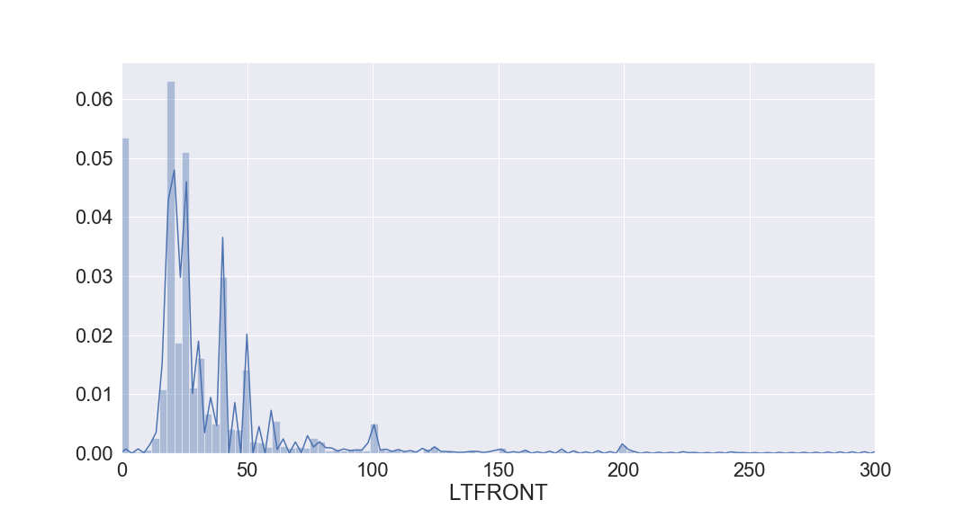

**11.**

**Field name:** LTDEPTH

**Field type:** int64

**Description:** lot depth in feet.

Properties that have lot depth < 300:

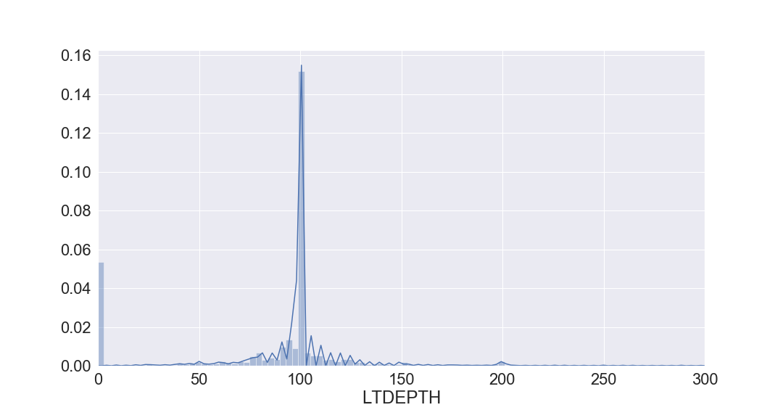

**12.**

**Field name:** EXT

**Field type:** object

**Description:** extension indicator; 'E' = extension, 'G' = garage, 'EG' = extension and garage

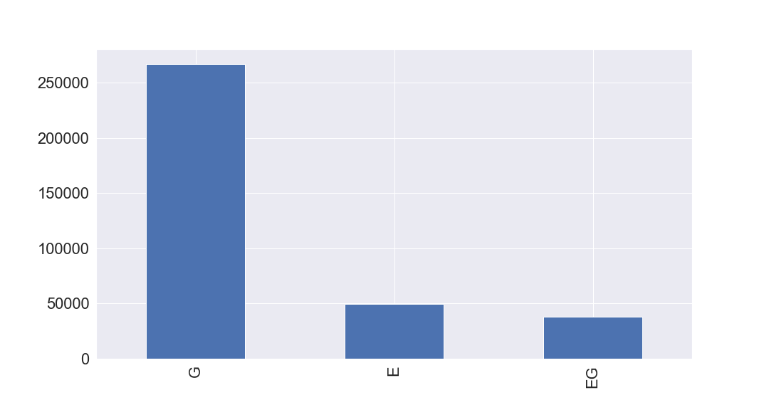

**13.**

**Field name:** STORIES

**Field type:** float64

**Description:** The number of stories for the building ( # of Floors).

Properties that have stories < 50:

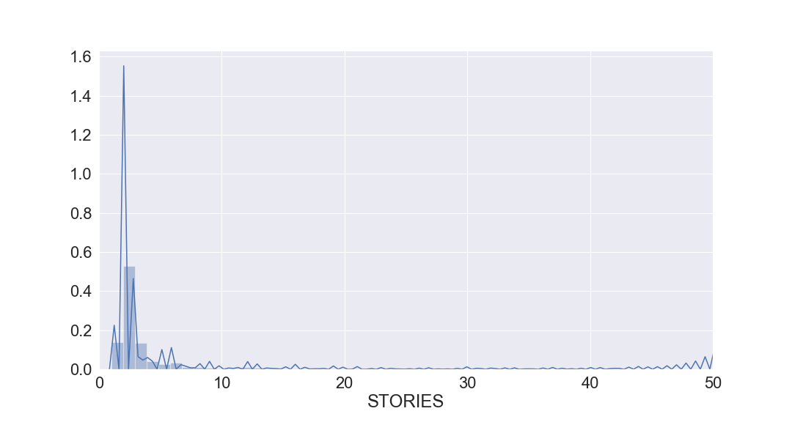

**14.**

**Field name:** FULLVAL

**Field type:** float64

**Description:** total market value.

Properties that have total market value < 2000000:

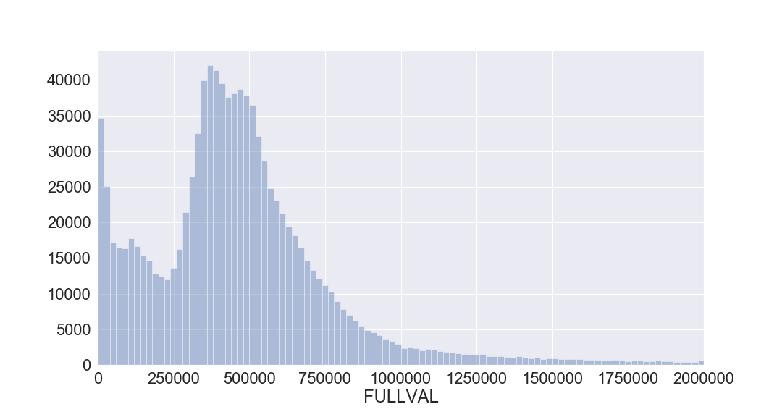

**15.**

**Field name:** AVLAND

**Field type:** float64

**Description:** actual land value.

Properties that have transitional assessed land value < 50000:

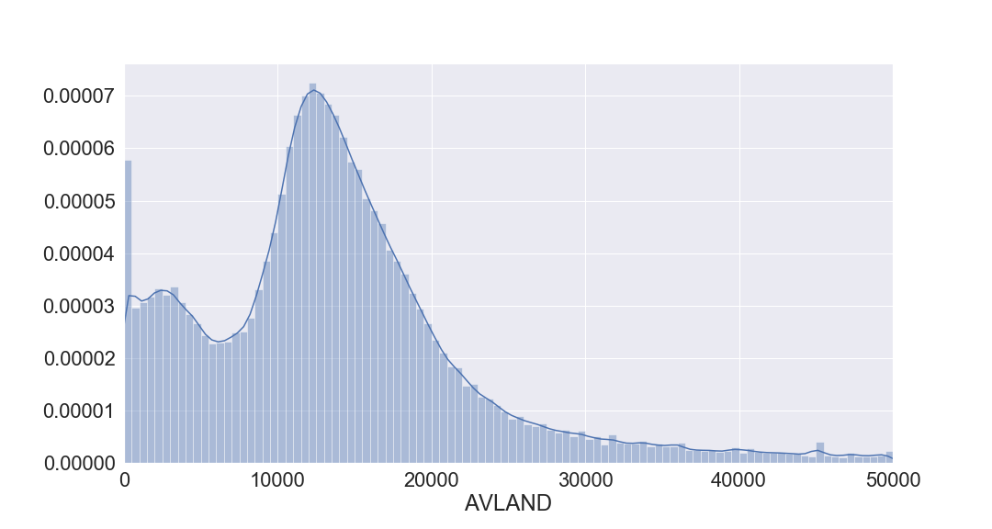

**16.**

**Field name:** AVTOT

**Field type:** float64

**Description:** actual total value.

Properties that have transitional assessed total value < 100000

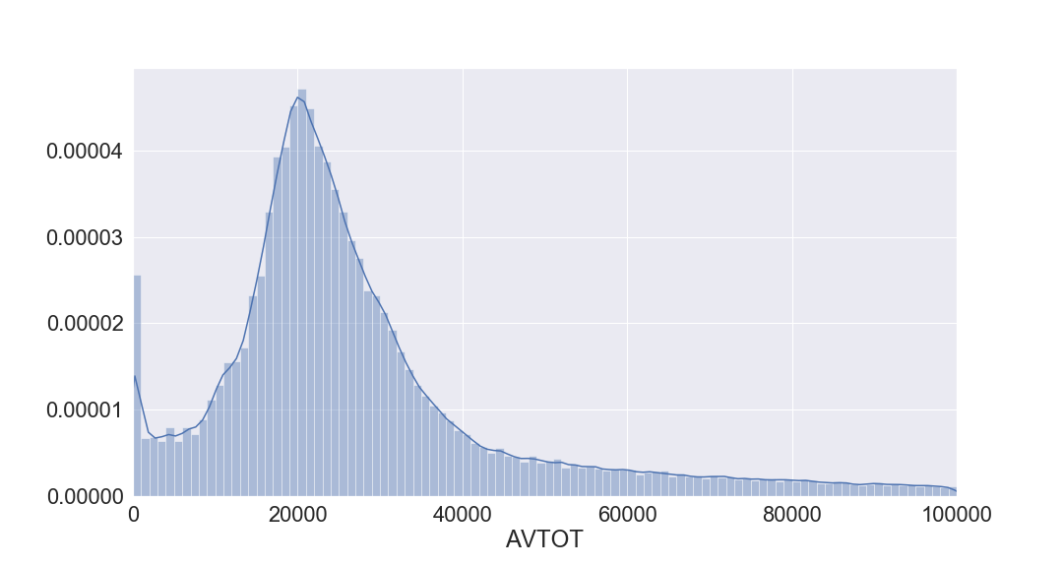

**17.**

**Field name:** EXLAND

**Field type:** float64

**Description:** actual exempt land value.

Properties that have transitional exempt land value < 20000:

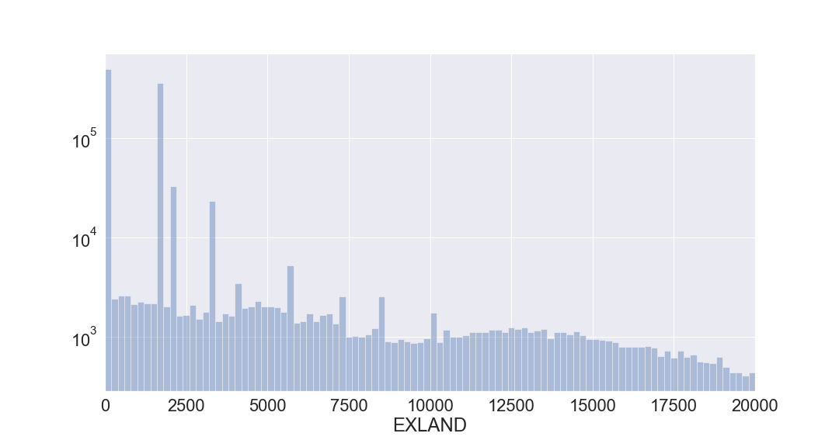

**18.**

**Field name:** EXTOT

**Field type:** float64

**Description:** actual exempt land total.

Properties that have transitional exempt total value < 20000:

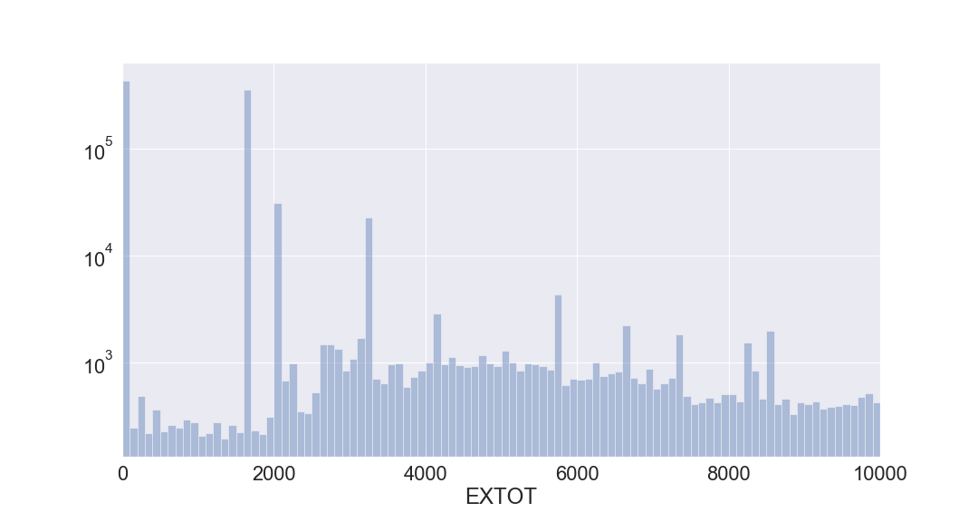

**19.**

**Field name:** EXCD1

**Field type:** float64

**Description:** exemption code 1.

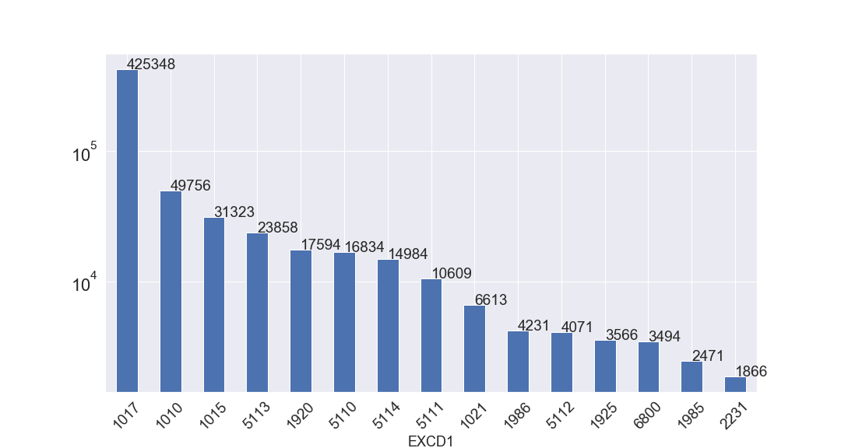

**20.**

**Field name:** STADDR

**Field type:** object

**Description:** street address. Top 15 addresses: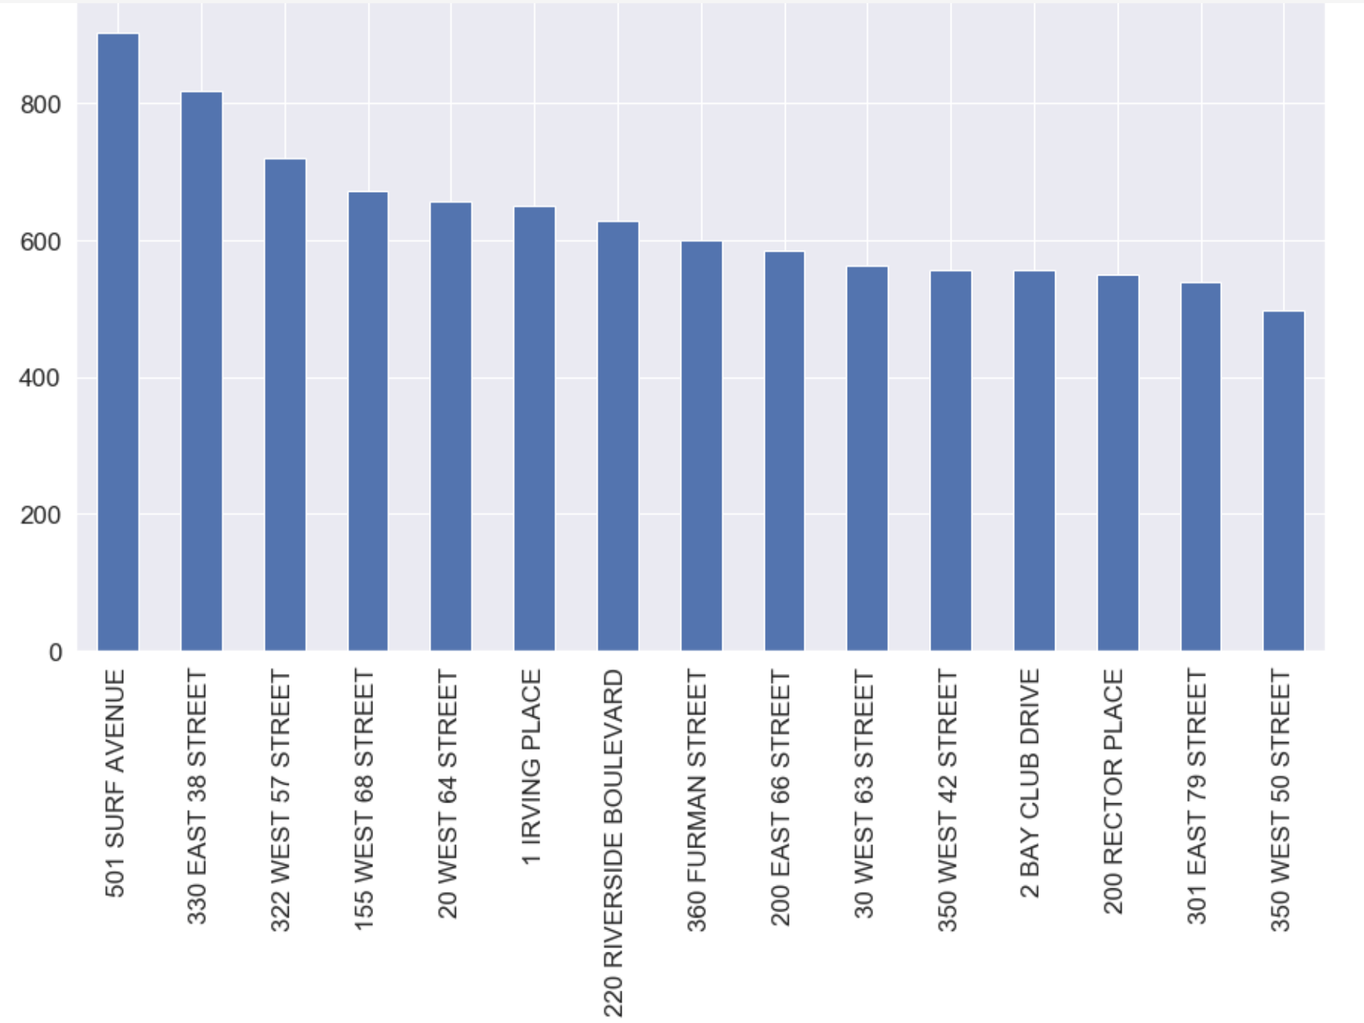

**21.**

**Field name:** ZIP

**Field type:** float64

**Description:** zip code.

Top 15 zip codes:

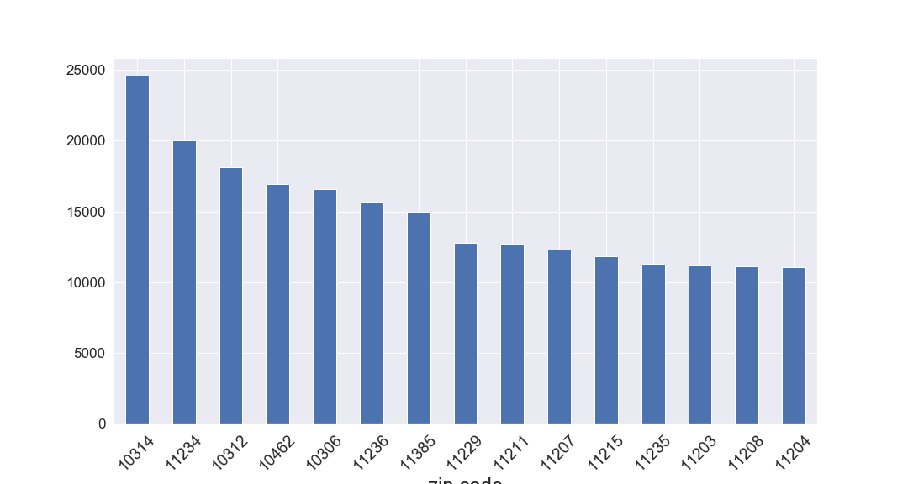

**22.**

**Field name:** EXMPTCL

**Field type:** object

**Description:** exempt class used for fully exempt properties only.

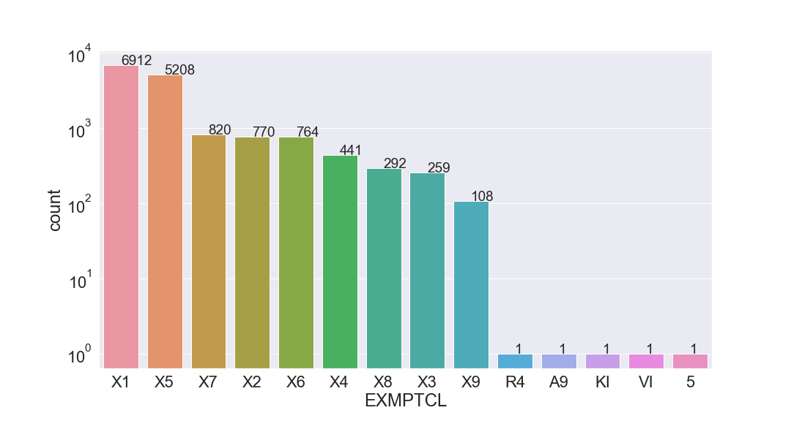

**23.**

**Field name:** BLDFRONT

**Field type:** int64

**Description:** building frontage in feet.

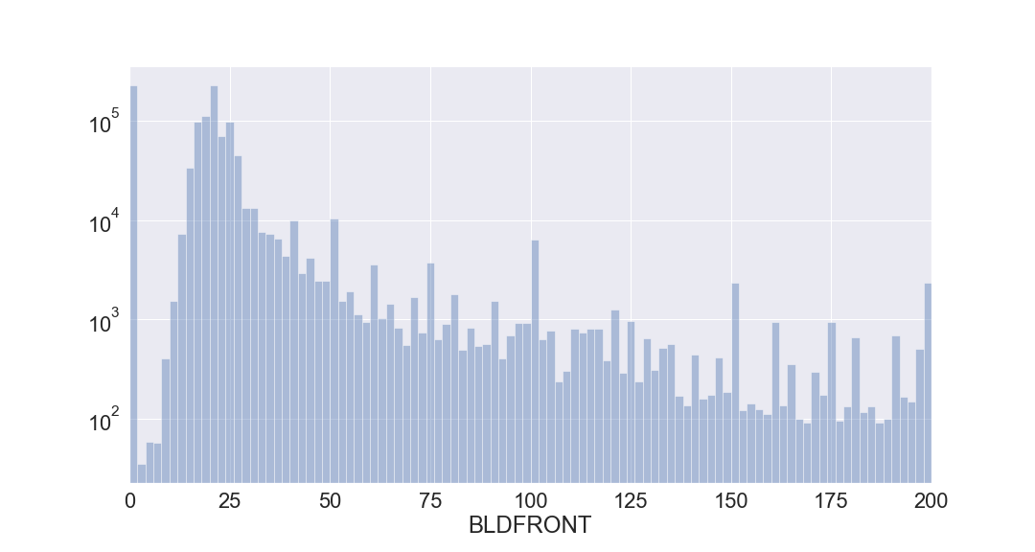

**24.**

**Field name:** BLDDEPTH

**Field type:** int64

**Description:** building depth in feet.

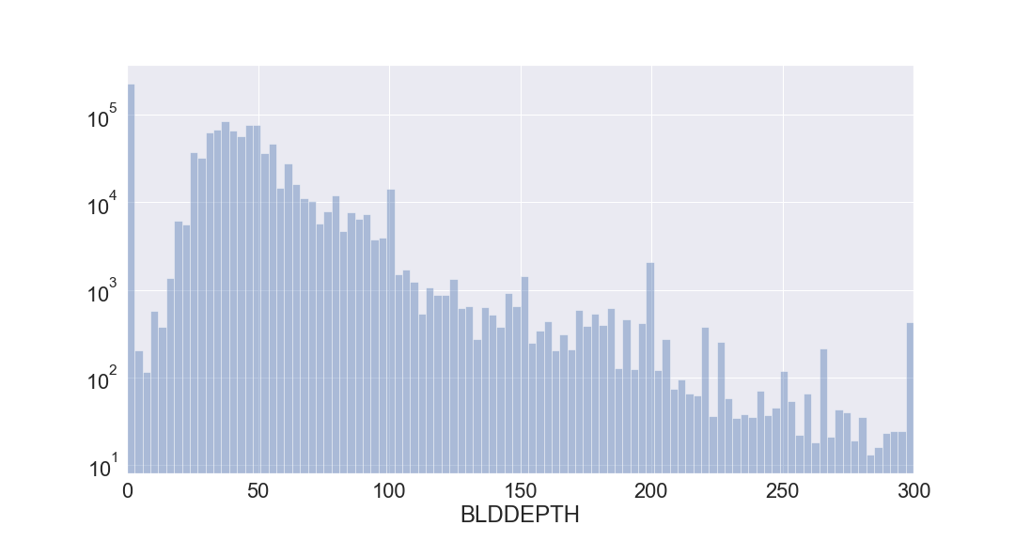

**25.**

**Field name:** AVLAND2

**Field type:** float64

**Description:** transitional land value.

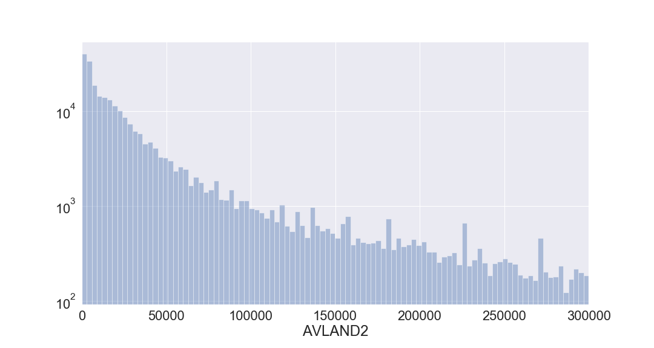

**26.**

**Field name:** AVTOT2

**Field type:** float64

**Description:** transitional total value.

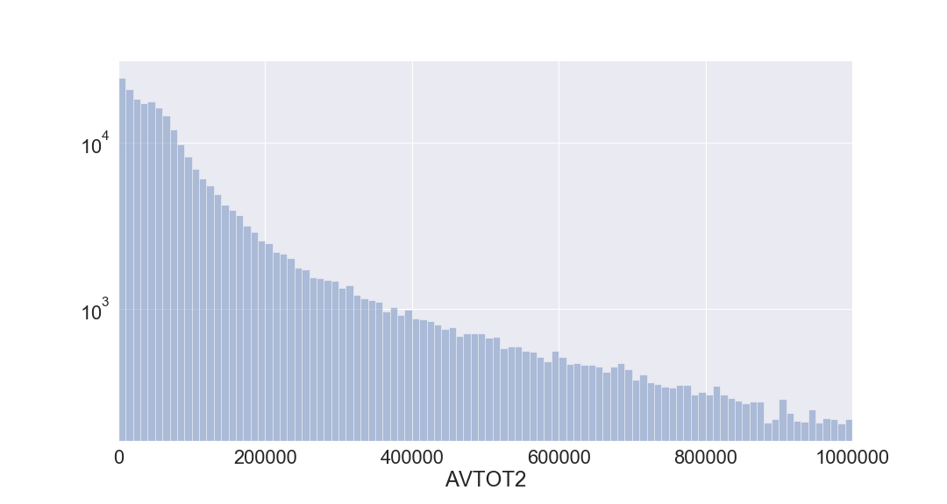

**27.**

**Field name:** EXLAND2

**Field type:** float64

**Description:** transitional exempt land value.

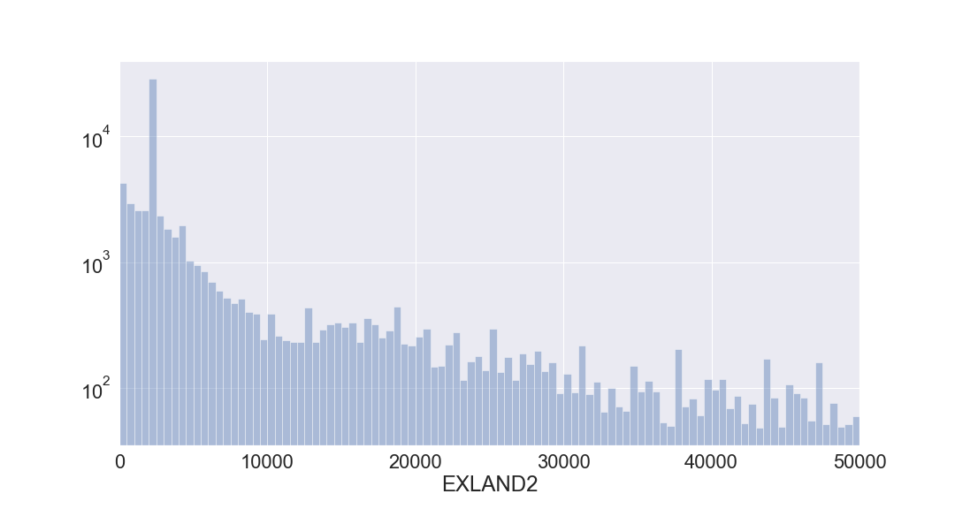

**28.**

**Field name:** EXTOT2

**Field type:** float64

**Description:** transitional exempt land total.

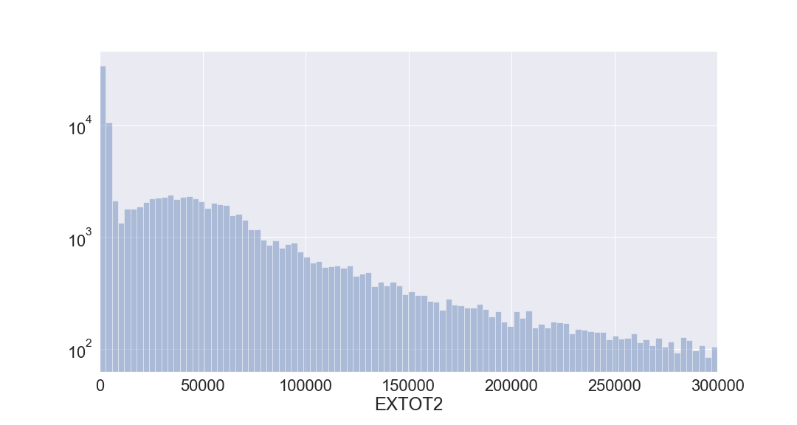

**29.**

**Field name:** EXCD2

**Field type:** float64

**Description:** exemption code 2.

Top 15 Exemption codes:

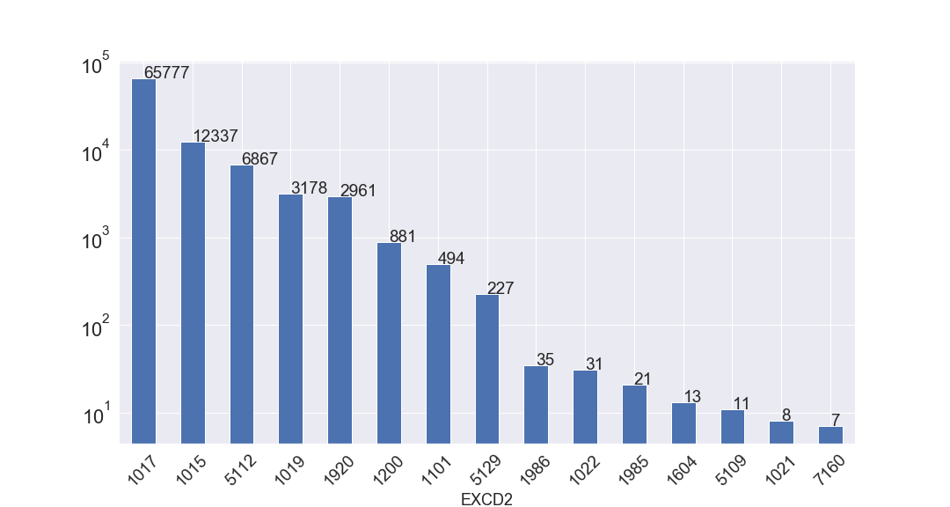

**30.**

**Field name:** PERIOD

**Field type:** object

**Description:** assessment period when file was created; FINAL.

**31.**

**Field name:** YEAR

**Field type:** object

**Description:** assessment year; 2010.

**32.**

**Field name:** VALTYPE

**Field type:** object

**Description:** AC-TR.